Factory Method Pattern

using System;

// Product Interface
interface IDocument
{
void Open();
}

// Concrete Products

class WordDocument : IDocument
{
public void Open()
{
Console.WriteLine("Opening Word Document");
}
}

class PdfDocument : IDocument
{
public void Open()
{
Console.WriteLine("Opening PDF Document");
}
}

class ExcelDocument : IDocument
{
public void Open()
{
Console.WriteLine("Opening Excel Document");
}
}

// Factory Interface

interface IDocumentFactory
{
IDocument CreateDocument(string type);
}

// Concrete Factory

class DocumentFactory : IDocumentFactory
{
public IDocument CreateDocument(string type)
{
switch (type.ToLower())
{
case "word":
return new WordDocument();

case "pdf":
return new PdfDocument();

case "excel":

return new ExcelDocument();

default:
Console.WriteLine("Invalid Document Type");
return null;
}
}
}
// Client

class Program
{
static void Main(string[] args)
{
string type = "pdf";

IDocumentFactory factory = new DocumentFactory();

IDocument document = factory.CreateDocument(type);

if (document != null)
{
document.Open();
}

Console.ReadKey();
}
}

Output :
- If Doc type is PDF
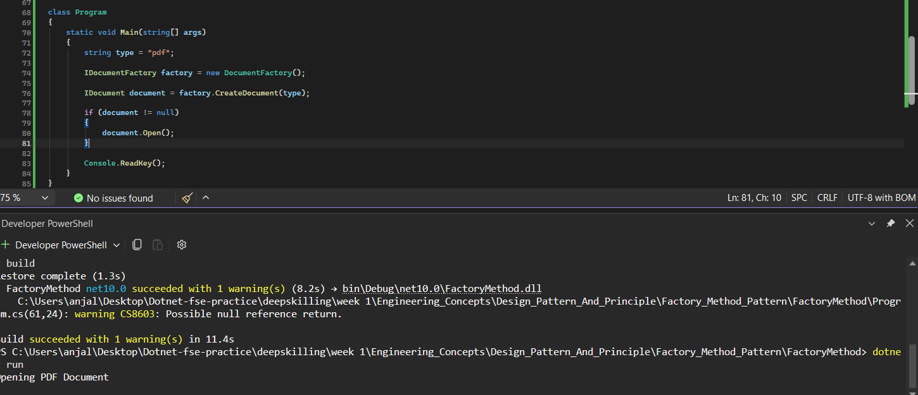

- If Doc type is WORD :
